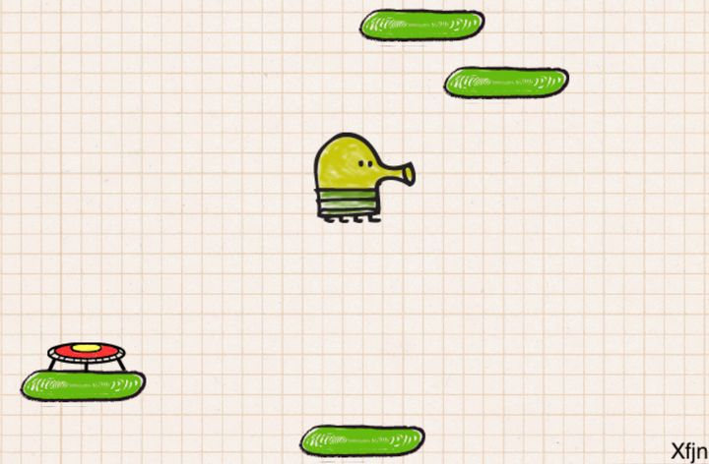

Hello Lizzie!

Last lesson James completed all the setup and linked our script to all the objects, so today we got straight into coding this script!  
  
To start, we used a FixedUpdate method, this is similar to the update method from earlier belts that runs constantly at set intervals. In unity we made the left arrow cause a value of -1 while the right arrow gives +1 in the horizontal axis, this can then be used to calculate our movement and then we stored it in a float (thats a number variable)!  
  
We lastly looked at an onCollisionEnter2D method which runs when our player object touches the top side of the platform. We firstly checked to see if our character was currently moving downwards to touch the platform, if true then it'll add some jump force to give us more power!  
  
Finally we simply added the scripts into the objects that needed them and Voila! Doodle Jump!! Great work today James, only one more game to go!!!!